**First Fit Algorithm**

#include<iostream>

using namespace std;

int main()

{

int bsize[10], psize[10], bno, pno, flags[10], allocation[10], i, j;

for(i = 0; i < 10; i++)

{

flags[i] = 0;

allocation[i] = -1;

}

cout<<"Enter no. of blocks: ";

cin>>bno;

cout<<"\nEnter size of each block: ";

for(i = 0; i < bno; i++)

cin>>bsize[i];

cout<<"\nEnter no. of processes: ";

cin>>pno;

cout<<"\nEnter size of each process: ";

for(i = 0; i < pno; i++)

cin>>psize[i];

for(i = 0; i < pno; i++) //allocation as per first fit

for(j = 0; j < bno; j++)

if(flags[j] == 0 && bsize[j] >= psize[i])

{

allocation[j] = i;

flags[j] = 1;

break;

}

//display allocation details

cout<<"\nBlock no.\tsize\t\tprocess no.\t\tsize";

for(i = 0; i < bno; i++)

{

cout<<"\n"<< i+1<<"\t\t"<<bsize[i]<<"\t\t";

if(flags[i] == 1)

cout<<allocation[i]+1<<"\t\t\t"<<psize[allocation[i]];

else

cout<<"Not allocated";

}

return 0;

}

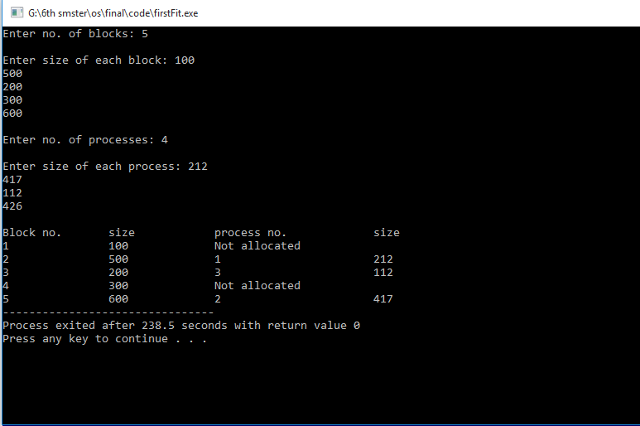**Output:**